

Essay / Assignment Title: Website Traffic Dashboard Analysis with Tableau

Programme title:VISUALIZATION AND STORY TELLING USING TABLEAU

Name: PRASAD NAREDLA

Year: 2025

CONTENTS

CONTENTS 2
INTRODUCTION 5
Project Background 5
Purpose of the Dashboard 5
Overview of the Report Structure 5
CHAPTER ONE: PLANNING THE WEBSITE TRAFFIC DASHBOARD 6
Identification of Primary Users 6
User Roles and Responsibilities 6
User Needs and Insights 6
Project Objectives 7
Key Performance Indicators (KPIs) 7
Justification of KPI Selection 8
Data Connectivity: Static vs Live Sources 8
Implications for Real-time Decision-Making 9
CHAPTER TWO: DATA PREPARATION AND TRANSFORMATION 10
Dataset Description and Source 10
Data Loading and Integration in Tableau 10
Data Cleaning and Formatting 10
How to Calculate New Columns 11
Calculated Fields and Transformations 11
Before and After Snapshots 12
CHAPTER THREE: CREATING THE WEBSITE TRAFFIC DASHBOARD 13
Dashboard Design and Layout 13
Description of Visualizations 15
Interactive Elements: Filters, Actions, Tooltips 16
Use of Basic and Advanced Tableau Features 17
Tableau Story Development 17
CHAPTER FOUR: ASSESSMENT AND ANALYSIS 18
Drawbacks of the Dataset and the Dashboard 18
Proposals for Adding More Data and Features 18
The possibility of using advanced analytics Features 18
CONCLUDING REMARKS 19
BIBLIOGRAPHY 20

Statement of compliance with academic ethics and the avoidance of plagiarism

I honestly declare that this dissertation is entirely my own work and none of its part has been copied from printed or electronic sources, translated from foreign sources and reproduced from essays of other researchers or students. Wherever I have been based on ideas or other people texts I clearly declare it through the good use of references following academic ethics.
(In the case that is proved that part of the essay does not constitute an original work, but a copy of an already published essay or from another source, the student will be expelled permanently from the postgraduate program).

Name and Surname (Capital letters):
PRASAD NAREDLA
.......................................................................................................................................

Date: 16/06/2025

INTRODUCTION

Project Background
To succeed today, digital businesses must study user behaviour on their website to improve their performance and marketing approaches. The project takes the viewpoint of a data analyst who works for a digital marketing agency. A growing e-commerce company has asked for a review and improvement of their website using data. Using Tableau, here we change raw data from website traffic into helpful, decision-ready insights.

Purpose of the Dashboard
It aims to give a clear, detailed snapshot of users, how they find the site and how engaged they are. Its main purpose is to benefit marketing managers, analysts and executives. Using bounce rate, session duration and conversion rate, the dashboard makes it easy for users to pick content strategies that work, switch away from poor-performing channels and draw more conversions. Dataset used in the dashboard is retrieved from https://www.kaggle.com/datasets/anthonytherrien/website-traffic.

Overview of the Report Structure
The following main sections cover planning the dashboard, prepping and transforming the data, assembling the dashboard, analyzing and interpreting the results and finally suggesting new ideas for the future. Every section describes an essential step in making the dashboard, using Tableau visuals, interactive tools and a concluding review of key findings for business users.

CHAPTER ONE: PLANNING THE WEBSITE TRAFFIC DASHBOARD

Identification of Primary Users
The purpose of the website traffic dashboard is to aid stakeholders in e-commerce. People who use this dashboard are mainly Marketing Managers, Digital Analysts and Business Executives. They are in charge of main tasks such as improving the website, setting up marketing plans and appraising the business overall.

User Roles and Responsibilities
How people use the dashboard depends on the role they have in their organization.
- Marketing Managers are in charge of supervising online marketing, planning how to use advertising money and making sure return on marketing investment is strong They depend on the dashboard to measure how successful each marketing channel is, see where the marketing hasn’t worked well and change strategies as needed.
- Digital Analysts dig into how users act, monitor ongoing marketing campaigns and make sure they are performing well. Using the dashboard, they dig into how long a session takes, how many users leave the site without interacting and view user activity to find any bumps in the user pathway (Al-Haraizah et al., 2025).
- Strategic decisions are a main responsibility for Business Executives. They pay most attention to important metrics such as conversion, the total number of sessions and increase in website visitors. With these insights in mind, decisions on investing, assigning resources and company planning are made.

User Needs and Insights
Different types of users look for different information which the dashboard is created to address.
- Marketing Managers should be able to quickly compare traffic sources (Organic, Paid, etc.) to find out which ones generate the most traffic and conversions. To see the quality of traffic from the campaigns, they make use of bounce rate and session length information. They depend on detailed information on how users interact, for example, average time spent on a page, the amount of pages visited and the point at which they leave the website. Because of this, they are able to improve the way the website looks and how it runs for users.
- Business Executives focus on overall trends and general summaries of how the business is doing. Things like the total number of visits by source, conversion rate and changes in traffic are used to check how close they are to their business goals and assess what they have received in return for their marketing investments (Anastasiia, 2022).
The dashboard responds to these requirements by showing data easily on the screen. Because of filters, tooltips and dynamic visualizations, learning from the data is simple and direct.

Project Objectives
The main goal of this project is to build a Tableau dashboard showing website traffic which will allow the client to:
- Check how the website runs with different types of traffic.
- Find out what people do and how they interact with content.
- Look at metrics related to outcomes such as sales or user sign-ups, to check how well your campaign is doing (David et al., 2022)
- Enable decision-making by giving managers real-time or nearly real-time insights.
The purpose is to develop an analytical tool that helps users take decisions based on data and improve customer interaction, marketing performance and results for the company.

Key Performance Indicators (KPIs)
How good a dashboard is depending on the choice of the right KPIs. For this project, the team decided to use these KPIs:
- Information about how long visits usually last on the site.
- Bounce Rate – This term shows how many visitors visit only one page and leave.
- The Conversion Rate is the percentage of visitors who do what is important, for instance, make a purchase or submit a form.
- Page Views Distribution – Demonstrates the typical number of pages’ users visit in one visit.
- Time on Page by Traffic Source – Details the average period users remain on landing pages based on the channel from which they accessed them.
- Finds out the total number of sessions that originate from various traffic sources (e.g., Organic, Referral, Paid, Direct).

Justification of KPI Selection
KPIs were only chosen if they mattered for studying traffic and making choices.
- Session duration can show how much time pages are visited. Users taking more time to view content usually shows they find it valuable.
- Bounce Rate is especially important to gauge how well your landing page works. Lots of people leaving your site quickly could mean either your content is off-target or the site is difficult to use.
- Conversion Rate is the ultimate proof that a marketing or user experience strategy is working by showing if visitors take the expected steps.
- Analyzing Page Views Distribution tells you how much of the site users are able to explore, hinting at positive content or trouble areas in the UX (Ilieva et al., 2024)
- Determining which traffic sources lead to the most engaged users can let you better optimize your marketing plans.
- With Total Sessions by Source, you learn where users are being directed from which helps direct your spending and marketing efforts.
The set of KPIs covers all the important aspects for performance such as users, visits and the achievement of goals.

Data Connectivity: Static vs Live Sources
In this project, the dataset does not change. It shows how web traffic changed over a certain period. During development and prototyping, people usually choose static datasets because it makes cleaning and displaying data less complicated. In a live environment, the dashboard is usually connected to real-time data such as what Google Analytics has to offer. Because live data integration is used, users are always presented with the latest information, as it is updated automatically.

Implications for Real-time Decision-Making
Because the dashboard works with static data, real-time changes are not possible. While history gives the ability to spot trends, show period statistics and review past events, it is not capable of detecting sudden drops in visitor numbers, unusual website performance or any sharp spikes in campaigns. Because they are real-time, dashboards allow teams to work efficiently. So, a marketing manager could stop a campaign that isn’t working well or focus extra budget on a popular keyword, after reviewing immediate feedback. Because of their monitoring, digital analysts are able to notice issues with the website that stem from outages or the rise in traffic thanks to promotions.

CHAPTER TWO: DATA PREPARATION AND TRANSFORMATION

A useful and helpful website traffic dashboard has its foundation far ahead of creating visuals—it relies on looking at, readying and working with the data. Getting to the finished dashboard also meant going through several key steps for the data such as sourcing, loading, cleaning, transforming and contextualizing the data.

Dataset Description and Source
The project uses a simulated website traffic dataset that is like what is available from Google Analytics. Apart from other details, it gives the Traffic Source (between Organic, Paid, Referral, Social and Direct) and checks Page Views, Sessions Length, Bouncing Users and site Conversion Rate. Though the data does not change, it is meant to show typical results from an e-commerce website. The structure made it possible to do detailed analysis since it was easy for anyone to use. It was easy to see the differences between traffic sources by using the session data in each row, making dashboard design efficient for this purpose. Because the data was so comprehensive, we could easily figure out which source brought us the most active users. Where is the data being lost? In which media does conversion happen most often?

Data Loading and Integration in Tableau
The following step was to bring the dataset into Tableau. Creating the extract went smoothly because Tableau’s simple interface understood the data types for me. Traffic Source was considered a dimension and session duration, conversion rate and bounce rate were handled as metrics. Being able to drag and drop dashboard objects made it simple to explore the different visuals in Tableau. But, the analysis of the data was not finished (Jongman et al., 2023). Even though Tableau was right to label data types correctly, when looking at Session Duration it was in raw seconds and Conversion Rate showed as a decimal which didn’t help explain the data right away. It was important to format and change these values so the dashboard was easier to understand.

Data Cleaning and Formatting
Data cleaning helped the visuals and made the information easier for users to grasp. Even though the data itself was clean, a few little but significant improvements had to be made. At first, the values for Bounce Rate and Conversion Rate were saved as decimals (0.2963 represents 29.63%) and this was not clear. The data was shown in percent form to follow industry standards and make the results easier to understand. This revealed clearly that Social had the highest bounce rate and Referral had the lowest. Attention was also needed to improve Session Duration. Stakeholders found it difficult to understand the data which was initially shown as seconds (e.g., “189”). A field was added to display this in minutes which helped to see that people using Referral traffic stayed longer on our site, for an average of 3.1255 minutes, while those coming from Direct traffic visited for only 2.6921 minutes on average.
Also, many technical field names such as “avg_session_dur,” were updated to readable phrases like “Average Session Duration.” Each small thing we did made the user experience much better.

How to Calculate New Columns
In addition to cleaning, calculated fields were important for finding more meaningful details. We were also interested in the way users navigated through the site by counting how many pages they visited. A “Page Views Bin” is made to organize sessions into different ranges. As a result, the histogram proved that over three quarters of users accessed 4–5 pages (708 sessions) and just a small number (49) got to view over 10 pages.
I also separate Time on Page by checking the traffic source by using a bubble chart. Here, we noted that people using Organic traffic spent the most time on the page (3,127 seconds), proving it is the best attention getter. The data was also organized into a treemap, allowing people to understand the relative success of each team beyond the mere numbers. Among the platforms, Organic generated the highest number of conversions (772.1) and did much better than Direct (211.4) and Social (264.3). The transformation made the most successful channels clear and easy to deal with first.

Calculated Fields and Transformations
Calculated fields proved to be very important for finding better insights than simple cleaning. For example, we tried to figure out how many pages each user looked at when viewing content. A way to group sessions by numbers of page views has been set up, called the “Page Views Bin.” As a result, the graph indicated that most visitors explored 4 to 5 pages on the site (with 708 sessions), while less than 5% (49 sessions) saw more than 10 pages. A further change was made by showing Time on Page separated by Traffic Source with a bubble chart. Right away, we noticed that Organic traffic had people spend more time on the page (3,127 seconds) than Social media or Links, indicating that it was the most engaging source. Conversion data was made into a tree map to show ratios instead of only the raw data. The top conversion value was 772.1 from organic traffic, much higher than Direct (211.4) and Social (264.3). This change made the top performing channels stand out and were simple to give priority to.

Before and After Snapshots
Before the cleaning began, the data just existed as a regular table of numbers, though it was accurate. Looking at a cell showing a “419” in the conversion column was unclear to begin with. Nevertheless, once the data was transformed, the number showed up in a visual story—Paid traffic’s conversion value (419.0) was featured as part of a treemap, with its size and color displaying how it compares to others.
Instead of just being seconds long, sessions showed how users interacted with the app and Referral and Organic had much longer sessions than the others. The data was changed so that percentages became the common approach instead of decimal numbers. This process made raw data into a helpful visual resource for people to make decisions.

CHAPTER THREE: CREATING THE WEBSITE TRAFFIC DASHBOARD

The aim behind making the traffic dashboard was to ensure it told a story, provided valuable insights and provided support for making decisions. Because Tableau was used, the dashboard was built to promote clarity, interactivity and usability for marketing managers, analysts and business stakeholders.

Dashboard Design and Layout
The dashboard was made to follow the principle of progressive disclosure, starting with the primary numbers and slowly revealing more detailed performance results. At the main part of the dashboard, you can see important KPIs such as Conversion Rate, Bounce Rate, Session Duration and Total Sessions, grouped by the type of traffic they represent. Under this, graphs provide more details on how users engage with the site such as time spent on each page, number of views per page and how long sessions last for each type of visitor. Patterns in the data are made easy to see because each section is color-coded and clearly identified. As seen on all these charts that Organic traffic is represented by orange to keep things uniform between graphs. Owing to its layout, both technicians and business managers can effortlessly move around without translating the raw numbers.
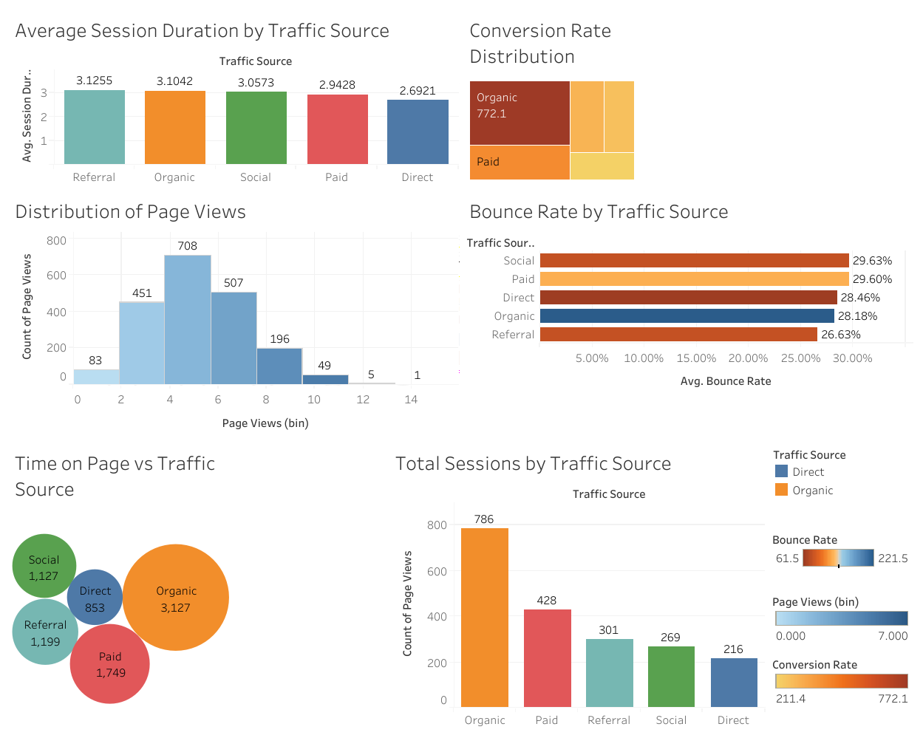
Source: https://public.tableau.com/app/profile/prasad.naredla5824/viz/Websitedatasetdashboard/Dashboard1

Story Design and Layout
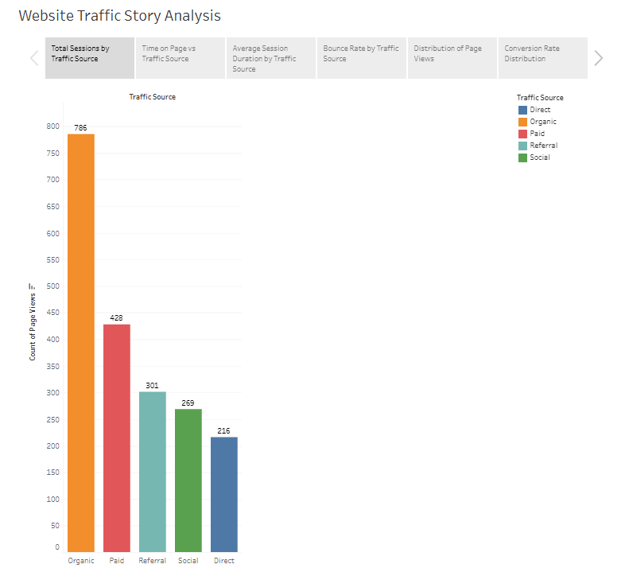
Source: https://public.tableau.com/app/profile/prasad.naredla5824/viz/Websitedatasetdashboard/Story1

Story of the Visuals
In combination, those images create the strong argument about the ways in which various traffic sources impact the performance of the websites. An example is used to explain the introductory statement about the most effective channel being the Organic traffic, which not only produces a high number of sessions and conversions; but also results in extended time (Muralidhar and Lakkanna, 2024). In comparison, Paid and Social traffic Black despite the high visibility has high rates of bounces, which shows that despite the attraction of users to the platform, high attraction rates may not result in meaningful experience (Liu and Wang, 2023). The referral traffic provides some kind of balance, as the conversion is moderate, and the average session length is the highest, indicating the particular interest. Every visualization will show the dots between traffic source, user behaviour and business value so that the stakeholders can easily assess that which techniques are effective, what needs improvements there and where the marketing technique should specifically target to get higher ROI.

Description of Visualizations
The dashboard includes several different graphs and charts which each illustrate a unique aspect of how users use the plan. It displays how each marketing channel is doing in a simple and easy-to-read chart. People visiting this site most often use Organic traffic, at 772.1 visits. This is much more than Paid (419.0), Referral (297.3) and Direct (211.4) visits. Larger and more colorful blocks show that the Most sessions have 4–6 page views, as seen on the chart where 708 sessions are the most common. This view outlines the usual length of a session and shows the areas where users engage the most. Bounce Rate by Traffic Source shows the bounce numbers for each source next to one another. Users who come from Social (29.63%) and Paid (29.60%), on the other hand, have higher bounce rates than those from Referral (26.63%).
Another bubble chart by traffic source which tracks time on page, has Organic on top, with the highest duration at 3,127. Because it shows a significant number of views and engaging comments, it supports considering Organic strategies more than Advertising.
Another way to see engagement is through the bar chart on Average Session Duration, with Referral (3.1255 minutes) and Organic (3.1042 minutes) being the standouts. At the end, a vertical bar chart is used to demonstrate that Organic traffic brings the highest number of sessions (786) out of all the traffic sources, confirming its top position. Charts and graphs were chosen to highlight analysis and to make it simple to notice trends right away.

Interactive Elements: Filters, Actions, Tooltips
The dashboard was made interactive to go beyond being just a static document. Special interactive features are included:
- Users can select traffic sources to focus just on metrics from a given channel. For example, clickingon the “Paid” button displays all the applicable graphics to show its performance.
- When you click on the Conversion Rate treemap, it updates the nearby visuals, so users don’t have to move from one page to another.
- Tooltips explain what something is by showing you a hint when you hover over it. Hovering on a bubble in the Time on Page chart gives you the exact value and the link to its source which allows you to analyze data in detail without causing any interference for other users.
By providing these features, users can look at data in their own ways, making self-service analytics possible.

Use of Basic and Advanced Tableau Features
Both basic and advanced parts of Tableau are collected on the dashboard. Bar charts, treemaps, histograms and built-in formatting options are included as basic elements. At the top end:
Raw metrics were changed into more usable forms, like bounce rate decimals to percentages and defining page view bins, with Calculated Fields. Using Level of Detail (LOD) expressions allowed for correct calculation of average values without introducing any aggregation distortion. Colors and their arrangement were used thoughtfully to make it clear to users which trends and outliers stand out. Because of this, the dashboard looked impressive and contained strong tools for analysis (Sadesh et al., 2023).

Tableau Story Development
A Tableau Story was made to lead users through the main findings. A story point is meant to answer a question, for example, “Which traffic source brings in the best conversion rate?” It is most suitable for presentations or reviews that are made by executives. Following a path built by the data scientists, managers can examine data with explanations and visuals next to it.

CHAPTER FOUR: ASSESSMENT AND ANALYSIS

Drawbacks of the Dataset and the Dashboard
Even though the dashboard shows useful information, we should be aware of its restrictions. One main shortcoming is having a fixed dataset that shows only one-time period, so it is not possible to monitor data as things happen. So, users have to wait to react to changes in traffic or campaign performance. There is not enough information in the dataset since user demographics, what devices they use and where they are located do not appear in it. No detailed tracking of goal funnels in the dashboard means it is challenging to follow how users reach and complete goals (Kavitha & Veena, 2024).

Proposals for Adding More Data and Features
To maximize the dashboard’s usefulness, try to link real-time data from Google Analytics API or BigQuery. It would mean that changes could be made quickly and there would be alert-based monitoring. Having demographics, what browser is used and location data would let you divide customers more precisely. Showing users as they go through the funnel reveals patterns in where people leave before completing a conversion. For further confirmation, showing historical trends compared over various periods would strengthen the performance review.

The possibility of using advanced analytics Features
With predictive analytics and machine learning models, the dashboard could start showing traffic projections in the future and the chances of a user taking an action. Strategic value could be increased by performing cohort analysis, churn prediction or propensity scoring. These new techniques would make the dashboard take action and alert stakeholders, so they can make moves in good time, rather than wait for issues to happen and then act.

CONCLUDING REMARKS

A Tableau-based website traffic dashboard was created as part of this project to give useful information about user behavior, the sources of traffic and how well conversions are happening. Analysis of Organic traffic demonstrates its strong role in boosting engagement, driving conversions and shows patterns in how sessions and pages are viewed that support strategic actions.

BIBLIOGRAPHY

Al-Haraizah, A., Abdelfattah, F. A., Rehman, S. U., Ismaeel, B., Mufleh, M., & Omeish, F. Y. (2025). The impact of search engine optimization and website engagement towards customer buying behaviour. Global Knowledge, Memory and Communication.
Anastasiia, N. (2022). Predictions of customer behaviour over ecommerce websites and anticipating their intention. Journal of Emerging Strategies in New Economics, 1(1), 12-21.
David, D. S., Anam, M., Kaliappan, C., Selvi, S., Sharma, D. K., Dadheech, P., & Sengan, S. (2022). Cloud Security Service for Identifying Unauthorized User Behaviour. Computers, Materials & Continua, 70(2).
Ilieva, G., Yankova, T., Ruseva, M., Dzhabarova, Y., Klisarova-Belcheva, S., & Bratkov, M. (2024). Social Media Influencers: Customer Attitudes and Impact on Purchase Behaviour. Information 2024, 15, 359.
Jongmans, E., Jeannot, F., Liang, L., & Dampérat, M. (2022). Impact of website visual design on user experience and website evaluation: the sequential mediating roles of usability and pleasure. Journal of Marketing Management, 38(17-18), 2078-2113.
Kavitha, G., & Veena, K. (2024, November). Research on User Behaviour Prediction in Social Networks Based on Deep Learning Model. In 2024 International Conference on Electronic Systems and Intelligent Computing (ICESIC) (pp. 40-45). IEEE.
Liu, Y. and Wang, Y., 2023. Empirical study on the factors affecting user stickiness of online visual art platform from the perspective of user experience. IEEE Access, 11, pp.60763-60776.
Muralidhar, A. and Lakkanna, Y., 2024. From Clicks to Conversions: Analysis of Traffic Sources in E-Commerce. arXiv preprint arXiv:2403.16115.
Sadesh, S., Khalaf, O. I., Shorfuzzaman, M., Alsufyani, A., Sangeetha, K., & Uddin, M. (2023). Automatic Clustering of User Behaviour Profiles for Web Recommendation System. Intelligent Automation & Soft Computing, 35(3).
Rafi, K. N., Gani, M. O., Hashim, N. M. H. N., Rahman, M. S., & Masukujjaman, M. (2025). The influence of 360-degree VR videos on tourism web usage behaviour: the role of web navigability and visual interface design quality. Tourism Review, 80(3), 725-741.
Verma, A., Arora, V., & Kanji, R. (2024). Modelling and Predicting User Behaviour.
Viglia, G., Dolnicar, S., Acuti, D., & Nicolau, J. L. (2024). If you want to learn about real behaviour, measure real behaviour. Journal of Sustainable Tourism, 32(11), 2245-2257.
Zhu, H., & Chao, Y. (2023). Drivers of the VR technologies user behaviour in e-commerce during the COVID-19 pandemic. Electronic Commerce Research and Applications, 62, 101319.

